Keep your Branch informed
Forward this email to your Branch Executives, Committee Members and other members to keep them up-to-date on important updates and information.
All Branch emails are also available on the Member Services Website

In this edition – September 2019

New Afghanistan products available through The Poppy Store

Liberation 75 tulip planting kit for Branches

A new Branch facility rental tool is available

Reminder: Poppy Manual updates

Your Legion Calendar for October and November

Free membership recruitment and renewal resources

2020 two-part renewal stickers delivered to Branches

New Afghanistan commemorative products in The Poppy Store
Honour and commemorate the service and sacrifice of those who served in Afghanistan through the purchase of hats, shirts and pins through the Royal Canadian Legion’s Poppy Store.
The Poppy Store offers an array of products to the Canadian public. Plus, Legion Members can log in to The Poppy Store to access exclusive products and savings. https://www.poppystore.ca/user-login

Liberation 75: Free tulip planting kits

Help commemorate the 75th anniversary of the Liberation of the Netherlands in 2020 with the Canadian Tulip Festival’s Liberation 75 tulip campaign. Through the campaign, Legion Branches can receive a free ceremonial garden planting kit.
There are several options available to organize commemorative activities at your Branch this fall:
Through the Canadian Tulip Festival
- Order Liberation 75 posters and an e-marketing kit for free to help promote the sale of tulip bulbs. A dollar from each bag of tulips sold will be donated to The Royal Canadian Legion.
- Order a free Liberation 75 Ceremonial Garden Planting and Blooming Kit, which includes marketing tools, instructions and bulbs.

https://liberation75.ca/Legion/

Through Schools and the Embassy of the Netherlands
The Kingdom of the Netherlands will be supplying 1,100 schools across Canada with a total of 100,000 bulbs this year. The schools will be encouraged to reach out to their local Legion branch to plan a ceremony on their school property. More details for Branches are to come.

Branch space rental

A new tool is available to help Legion Branches assess groups or organizations requesting to rent Legion facilities. The Space Rental Request Form supports the Branch in taking appropriate steps to confirm that the group or organization’s views, purposes and the nature of the event itself align with the Royal Canadian Legion founding Articles of Faith, General By-laws and hate group policy.

https://app.clickdimensions.com/blob/legionca-a3lro/files/public-relations_branch-rental-checklist_2019e.docx?1568308696007

Reminder: Poppy Manual updates
As we get closer to the Poppy Campaign, a reminder that important amendments have been made to the Poppy Manual. These include changes to authorized Special Use Expenditures, and expenditures that are no longer authorized.
https://app.clickdimensions.com/blob/legionca-a3lro/files/poppymanualmodifications_april2019.pdf?1568308965966

https://app.clickdimensions.com/blob/legionca-a3lro/files/poppymanual_eng_201904.pdf?1568308985913

Your Legion calendar: October–November 2019
This calendar lists upcoming commemorative days of relevance to The Royal Canadian Legion that raise awareness of an issue, commemorate a group or event, or celebrate an important topic. Branches may wish to promote these dates or organize related activities.
DATE | EVENT
1st week of October | National Family Week
October 6–12 | Mental Illness Awareness Week
October 10 | World Mental Health Day
October 14 | Thanksgiving
October 14 | Van Doos anniversary (1914)
October 17 | International Day for the Eradication of Poverty
October 24 | Anniversary of the United Nations (1946)
October 25 | Poppy Campaign begins
November 1 | Announcement of National Silver Cross Mother
November 8 | Aboriginal Veterans Day
November 11 | Remembrance Day
November 11 | First World War ends – Armistice Day (1918)
November 12 | Passchendaele (1917)
November 18 | Battle of the Somme (1916)

Get access to Marketing and PR resources

Marketing and communication tools are available online for Branches, including brand guides, recruitment materials, public relations supports, promotional resources and more.
Visit the Member Services Website under Branch and Command Resources / Marketing and Public Relations.
Preprinted promotional materials are also available for free from Legion Supply.

http://portal.legion.ca/docs/default-source/branch-and-command-resources/supply/catalogue_fall_e.pdf?sfvrsn=4
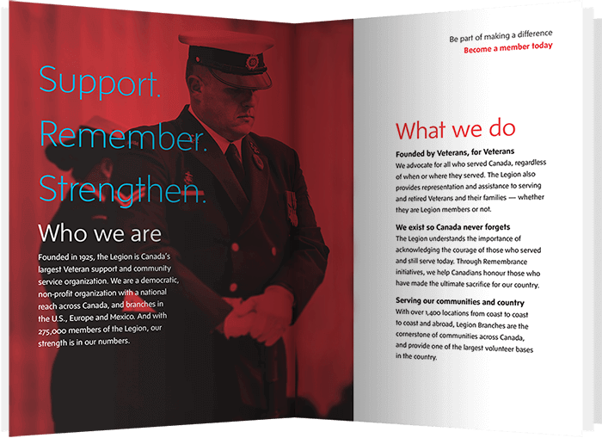
Get free membership resources
Find free membership recruitment and renewal resources available to Branches through the Legion Supply Department – order yours today!
VIEW RESOURCES

PR Tip of the Month
Know your audience
A key part of good PR is knowing your audience. Whether you’re trying to reach members, the media, or the corporate world, think about the ways they can be most effectively reached and structure your communications (e.g. letter, social media, ad campaign etc.) accordingly.
Have questions or need advice? Contact your Command Public Relations Officer or Nujma Bond, Dominion Command Communications at nbond@legion.ca.

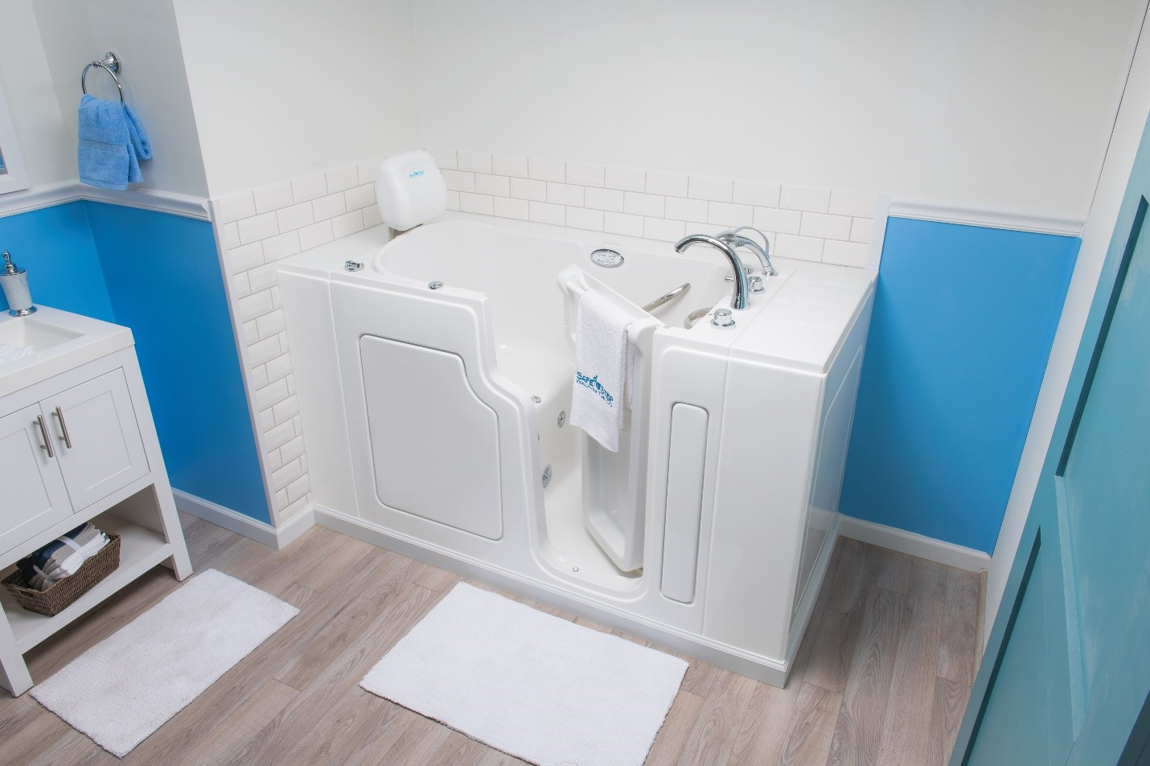
Member Benefit Partner: Safe Step Walk-in tubs help those affected by mobility issues, making bathing easier than ever before.
Safe Step is pleased to offer Legion members $2000 off the cost of a walk-in tub with full installation. For every Safe Step walk-in tub sold we will also donate $225 to the Legion. As part of Canadian Safe Step Walk-In Tub Co.’s initiative to give back, we are proud to partner with The Royal Canadian Legion’s Member Benefits Package and to help our veterans through various programs.
For many people with mobility issues or physical disabilities, what once were considered routine tasks, such as taking and enjoying a bath, can now be perceived as dangerous and challenging. Slippery surfaces, high step-ins and lack of support bars can cause falls in the bathroom that carry serious health consequences.
At Safe Step we understand that to enjoy bathing again, we need to provide the safest walk-in tub in the market that will help our customers remain safe, comfortable and independent. Safe Step walk-in tubs are loaded with safety features such as a low step-in, anti-slip surfaces, safety grab bars and a wider door that make the bathing experience safe again.
Canadian Safe Step tub Co is a Canadian owned business supplying the highest quality American made walk-in tubs with the most certifications and the best warranty in the industry.
https://safesteptubs.ca/rcl/
Your Legion online

The Legion’s new Member Services Website is a gateway to convenient branch-specific and membership information and services, including simplified new member sign-ups and renewals.
Branches can login to portal.legion.ca with the username and password provided.

► Membership renewals are getting underway!

2020 Two-Part Renewal Stickers
All 2020 Membership Renewal Stickers have now been delivered to Branches. If you have not received your stickers, please contact Member Services.
The package also included a message from the Dominion Command Membership Committee Chairman. You can read the message here.
Auto renewal update
Members who have signed up for auto renewal will receive an email in early October notifying them that their 2020 membership will be processed to their credit card on file in late October.
Early Bird Stickers
Early Bird Stickers are now available for order through Legion Supply. Call Legion Supply at 888-301-2257.
Free Early Bird promotional posters and member letters are also available for order, or can be downloaded from the Member Services Website, under Branch and Command Resources / Membership.
Make membership renewal easy for your members!
87% of Branches provide over 230,000 Legion Members with the opportunity to renew their local Branch membership online. Please ensure your Branch Rates are entered and up-to-date.
UPDATE YOUR BRANCH RATE
Use the Branch Membership Renewal Strategy
Members are the strength of the Legion, and our most valuable resource. Use the attached Branch Membership Renewal Strategy to guide your renewal efforts.

https://app.clickdimensions.com/blob/legionca-a3lro/files/branchrenewalstrategyenglish.pdf?1568309108245
2020 per capita tax rates

The 2020 per capita tax rates are now available online. They are effective September 01, 2019 for the 2020 membership year. 2019 online Branch rates will be automatically copied over to 2020 for Branches.
If you have a membership fee rate change, please update online or contact Member Services directly.

► | YOU’VE GOT MAIL!

Please ensure you are accessing your Branch email by clicking ‘WEB MAIL’ on the left-side menu of the Member Services Website.
If you have any questions please contact Member Services and we will be pleased to assist.
1-855-330-3344 or membership@legion.ca
Office Hours: Monday – Friday, 8:30 – 4:30 EST

