BASIC DRILL MOVEMENTS AND COMMANDS

Words of command MUST be given in a clear, loud and precise voice.
There are two distinct elements to a drill command, and they are;
- The Cautionary Command; and

- The Executive Command.

- The Cautionary notifies the Platoon/Colour Party, that a drill movement will occur. There is no movement by anyone during this phase. Ex. Colour Party – Carry Colours! No Movement.
- The Executive command is a short and sharp order which directs the Platoon/Colour Party to perform the drill movement. Ex. Colour Party – Carry Colours! Carry out the movement.

Position of Attention
The position of attention is one of readiness in expectation of a word of command. Alert exactness in this position is important and, therefore, members should not be kept at attention longer than necessary. At the position of attention:
A. The heels are together and in line;
b. The feet are turned out to form an angle of 30 degrees;
c. The body is balanced and weight is evenly distributed on both feet;
d. The shoulders are level, square to the front.
e. The arms are hanging as straight as their natural bend will allow with elbows and wrists touching the body;
f. The wrists are straight, the back of the hands held outwards
g. The fingers are aligned, touching the palm of the hand, thumbs placed on the side of the forefingers at the middle joint with the thumbs and back of the fingers touching the thighs lightly and the thumbs in line with the seam of the trousers;
h. The head is held erect, neck touching the back of the collar, eyes steady, looking at their height, and straight to the front.
- No part of the body should be strained.
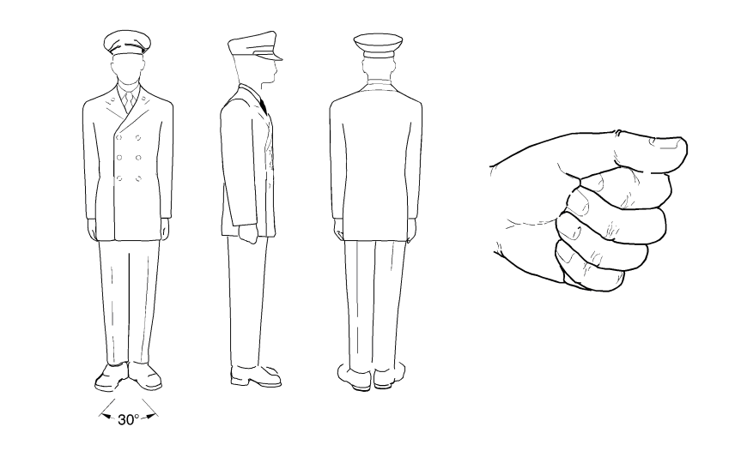

Position of the Stand at Ease
The position of standing at ease is an intermediate position between attention and standing easy. It allows no relaxation, but can be maintained, without strain, for a longer time than the position of attention.

Asic
On the command “STAND AT - EASE”:
a. Bend the left knee;
b. Carry the left foot to the left, straightening it in double time, and place it smartly flat on the ground, with the inside of the heels 10 inches (25 cm) apart;
c. Simultaneously, with a quick motion, bring the arms behind the back, stretched to their full extent, and place the back of the right hand in the palm of the left, with thumbs crossed right over left, the fingers together and extended
d. Balance the body with the weight evenly distributed on both feet.

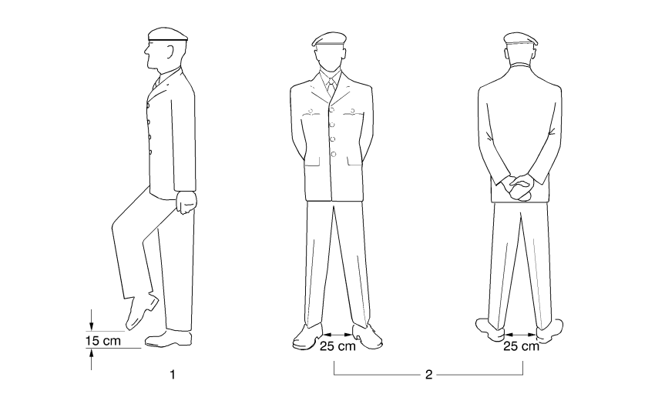

Stand Easy.
The position of stand easy is ordered when it is desirable to permit the members to relax.

This command is only given when the members are in the position of stand at ease. On the command “STAND EASY”:
- Close the hands and bring the arms to the position of attention
- Following a standard pause, relax.

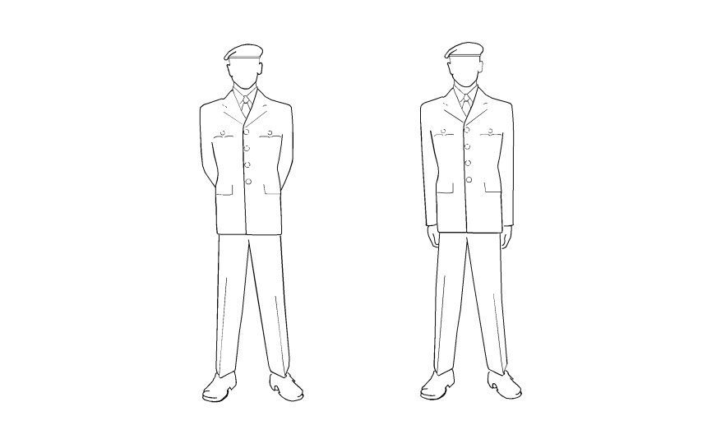

Stand at Ease from Stand Easy.

On a cautionary command such as steady up
“COLOUR PARTY”, “PARADE”, etc., assume the position of stand at ease.

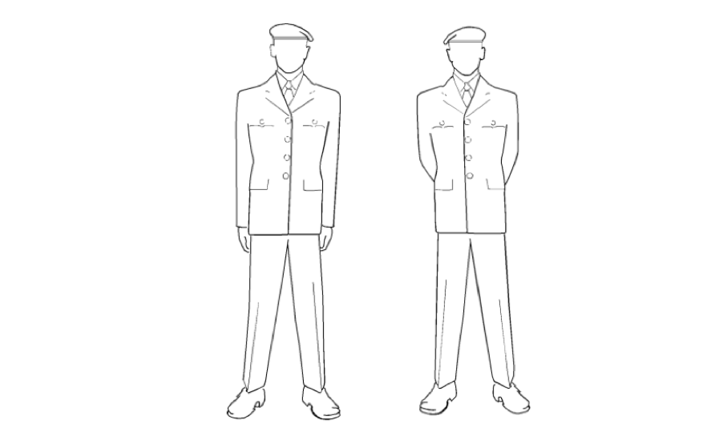

Attention from Stand at Ease.
On the command “ATTEN-TION”:c
- Bend the left knee and shift balance to the right foot;
- Straighten the left leg in double time, place the foot smartly on the ground, toe touching first, followed by the heel, and with heels aligned;
- Simultaneously, with a quick motion, bring the arms and hands to position of attention.
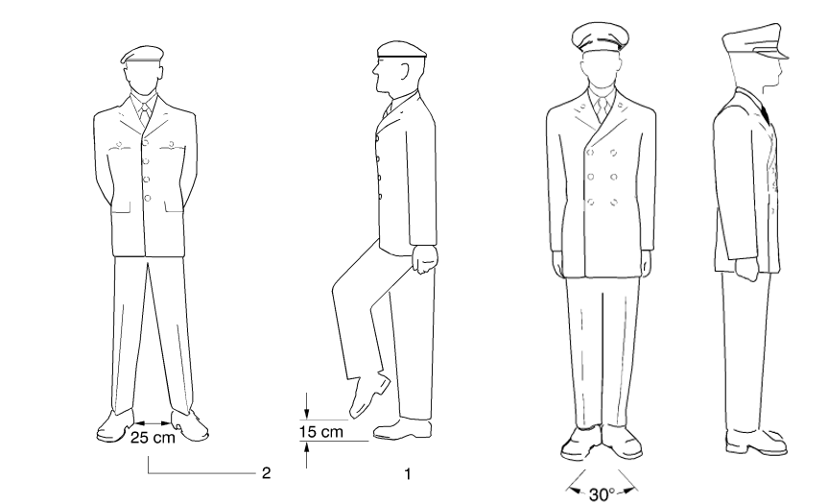

Remove Headdress
The order to remove headdress may be given when it is customary to do so. This practice is normally performed at the
call of the Parade Commander, Sgt-at-Arms or person in charge.
THE PARADE IS AT ATTENTION
On the command “REMOVE HEADDRESS”:
  - Bring the right hand to the front of the headdress by the shortest route
  - Grasp the headdress between the thumb and fingers, with the fingers aligned and parallel to the shoulders as much as practicable;
  - After the standard pause of 2-3, maintaining the bend in the right arm, cut the upper arm to the right side of the body and the forearm parallel to the ground;
  - Bring the right hand to the centre of the body;
  - Maintaining the grasp on the headdress, hold the headdress above the hand and in the centre of the body

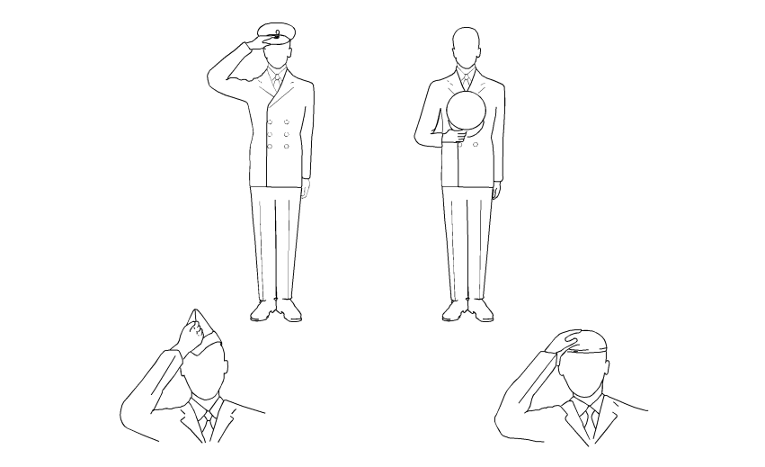

Replace Headdress.

On the command “REPLACE -HEADDRESS”:
- Replace the headdress using both hands

- Following a standard pause, resume the position of attention by cutting both arms to the side;
- Comrades are then ordered to “STAND AT - EASE ... STAND - EASY”, at which time they adjust their headdress.

DRESSING:
Dressing can be performed in one of three formats:
1: On the command “RIGHT - DRESS”:
- The right marker of the front rank stands fast
- Following a standard pause of 2-3, the right marker does not move while the remainder turns head and eyes to the right as far as possible without straining;
- Simultaneously, the front rank, except for the right marker, shoots the right arm to its full extent behind the shoulder of the member on the right, hand closed as in the position of attention, back of the hand upwards and arm parallel to the ground;
- Following a standard pause of 2-3, the right marker continues to stand fast while the remainder takes up correct alignment, distance and covering, taking short, quick paces until they are in the correct position. movement starting with the left foot. The distance is correct when the right hand touches the left shoulder of the person on the right.
As a guide to taking up correct alignment, each member, except those in the right marker position, moves to a position from which the lower portion of the face of the second person to the right can just be seen. Correct covering is taken up by glancing to the front without moving the head.

2. “ELBOW DRESSING ... RIGHT - DRESS”; i. The front rank, except for the right-hand member, places the right hand on the hip, fingers closed, pointed down and extended forward, thumb to the rear and elbow straight out to the side; ii. The point of the elbow touches the member on the right when the distance is correct.
3.“SHOULDER DRESSING ... RIGHT - DRESS” - each person’s arms remain at the position of attention and the correct distance only allows enough room between members for freedom of movement.

On the command “LEFT - DRESS” - the same drill movements are followed except the head and eyes are turned left and the left arm is used. The left-hand member/file stands fast, as applicable.
When dressing is complete, the command “EYES - FRONT” is given. Members shall snap heads and eyes to the front and, as applicable, cut arms smartly to the position of attention without slapping the thighs.
Drill Movement
rill Movements

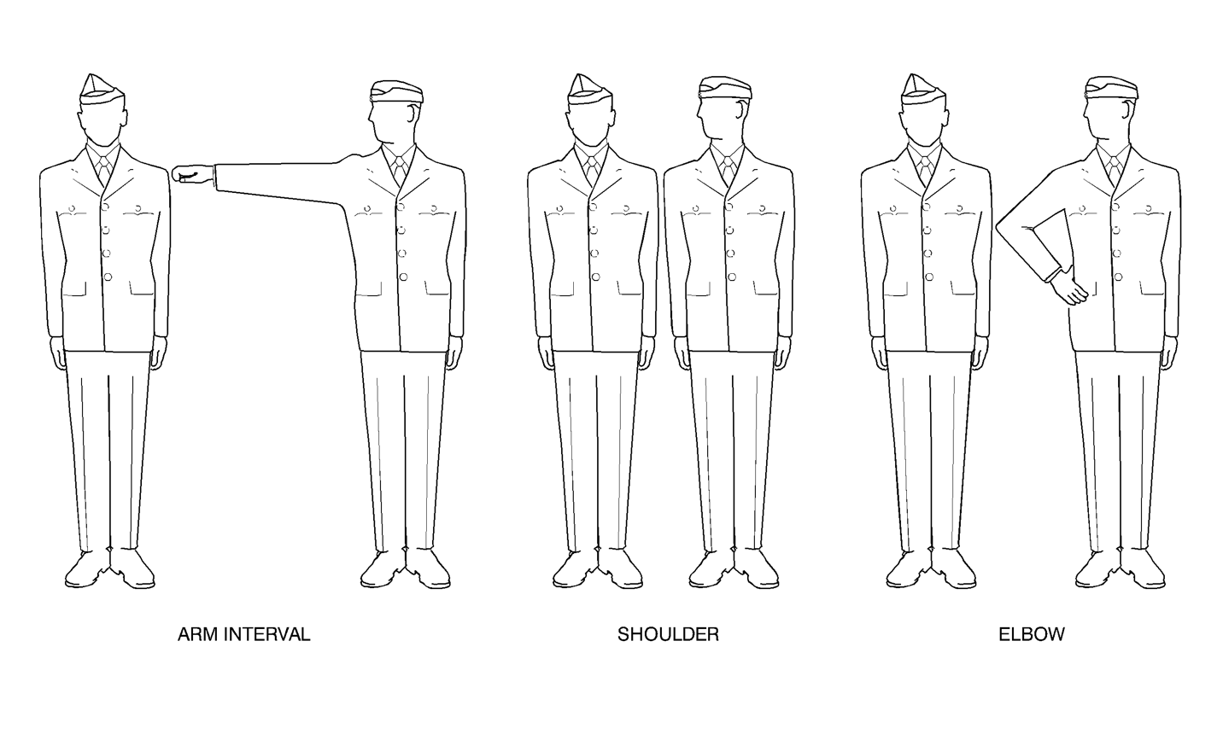

SALUTING:

With the paying of Compliments being formal marks of trust and courtesy, the military hand salute is noted as a traditional demonstration of showing respect and in particular, respect for office. Although the method of saluting varies under the circumstances, the paying of compliments is a fundamental requirement that is indispensable to service discipline.
Unification of the Canadian Armed Forces brought us a different method of hand salute, with the head held high, bringing the right hand smartly to a position over the right eyebrow, with the palm facing down, the fingers fully extended and the elbow perpendicular to the shoulder. The motion is short way up – short way down. The Royal Canadian Legion has adopted this method.

You are expected to salute during the following, if wearing head dress:
When the Canadian Flag is raised or lowered and when it is carried past in a parade. All present should face the flag and remain silent. Comrades in uniform shall salute and all wearing a hat should remove it.
During the playing of O Canada, Last Post, Rouse, The Royal Anthem, during a March Past when the Colours are passing by you, when laying a wreath, and when laying a poppy or maple leaf.

Saluting at the Halt

To perform a salute:
- Bend the right elbow and open the palm of the right hand;
b. Force the right hand by its shortest route to the forehead so that;

- The palm of the hand is facing down;
ii. The thumb and fingers are fully extended and close together;

iii. The tip of the second finger is one inch (2.5 cm) above and in line with the outside of the right eyebrow;
iv. The hand, wrist, and forearm are in a straight line;
v. The elbow is in line with the shoulders;
vi. The upper arm is parallel to the ground.

- To complete the salute, bring the hand sharply to the position of attention by the shortest route without slapping the thigh, closing the hand after the forearm is lowered below the shoulder level.

^{SALUTING TO THE RIGHT (LEFT)}
- On the command TO THE RIGHT (LEFT) SALUTE BY NUMBERS, SQUAD – ONE, saluting shall be executed as detailed previous, except that:
- the head and eyes shall be turned smartly to the right (left) as far as possible without straining;
- when saluting to the left, the right hand, wrist and arm are brought further over to the left to the correct position in line with the outside edge of the right eyebrow; and
- when saluting to the right, the arm is moved to the rear, with the tip of the second finger remaining in line with the outside edge of the right eyebrow.
- On the command SQUAD – TWO, the hand is brought sharply to the position of attention, and simultaneously the head and eyes are turned smartly to the front.
- On the command TO THE RIGHT (LEFT) – SALUTE, the two movements are combined. The standard pause shall be observed between movements.SALUTING TO THE RIGHT (LEFT)
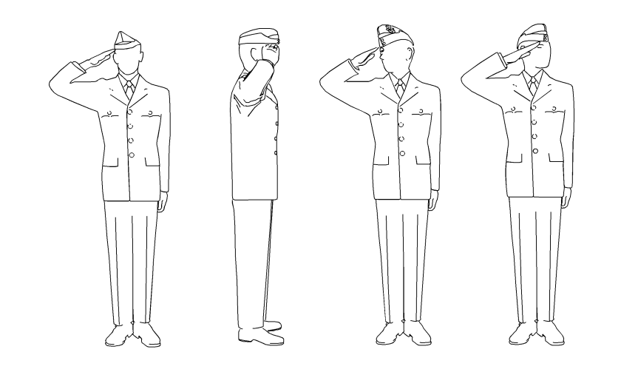

Why is it that Legion officers are rarely saluted?

Legion Officers are certainly saluted when they are reviewing parades, however, the likely answer is that we traditionally drop our rank at the door when we join the Legion. The secondary likely answer is that most current Legion Officers are not “commissioned officers” as prescribed in Canadian Armed Forces regulations;

In certain circumstances, normally parade oriented, it is appropriate for a Legion member to salute a Senior Legion Member or Military Officer/ Dignitary out of respect for the Senior Office.

Turning at the Halt

On the command “RIGHT - TURN”:
- Brace both knees, arms are at the sides and body erect;

- Turn 90 degrees to the right by pivoting on the right heel and left toe, simultaneously, raising the left heel and right toe;
- On the completion of the movement, place the weight of the body on the right foot and brace the left leg with the heel off the ground;

- Following a standard pause, bend the left knee, straightening it in double time, smartly placing the left foot beside the right to assume the position of attention;
- The “LEFT - TURN” is achieved through the same movements, using the opposite feet and directions;

- The “LEFT/RIGHT - INCLINE” is completed doing the same movements; however, the turn is only 45 degrees;

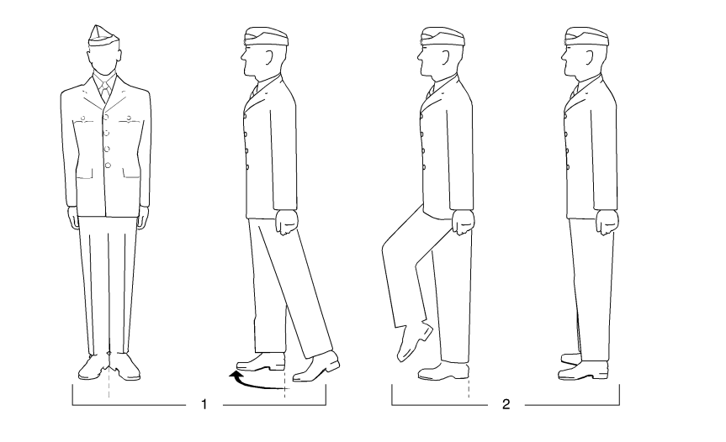

About Turn at the Halt

The “ABOUT - TURN” is the same as for the right turn except that the pivot to the right is made through 180 degrees. Balance is maintained by bracing the legs and locking the thighs.

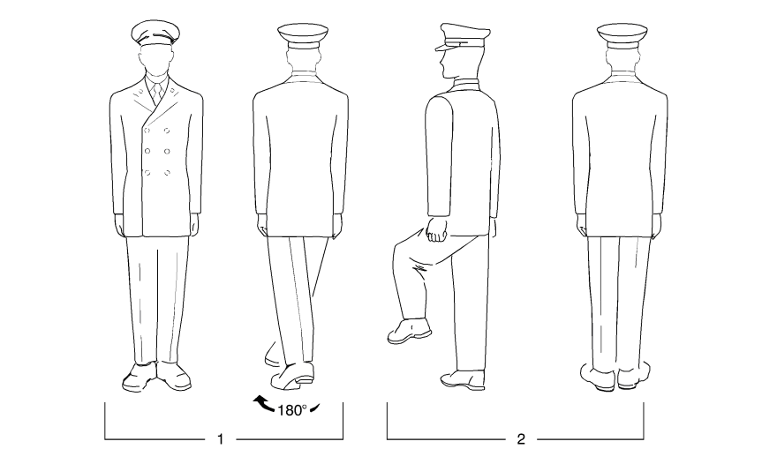

Wreath laying.

There are many occasions when members will be called upon to either place a wreath or to be a wreath bearer.
- When placing a wreath, the person placing the wreath and the bearer should march together to the memorial or cenotaph, with the bearer slightly behind and to the left of the person placing the wreath.
- In certain circumstances, it would be permissible for the wreath bearer to march to the right of the person laying the wreath if that person required assistance to the designated area where the wreath is to be placed.
- The individuals will halt and the bearer will hand the wreath, with the ribbon or banner facing the person laying the wreath.
- The wreath layer will step forward if necessary and place the wreath in the designated location.
- Upon placing the wreath, the wreath layer and the bearer take one step backward, salute, turn right and march back to their position;
- In some ceremonies, poppies are laid on wreaths that have been placed for that purpose. If this is
to be the case, then the person placing the poppy shall march up to the wreath, halt and kneel forward and place the poppy. After the poppy has been placed on the wreath, the person shall resume the position, take one-step backward, salute, turn right and march back to their position;
- The above-noted wreath-laying procedures are appropriate for outdoor or indoor cenotaph services, providing that the bearer is wearing headdress. For any Legion purpose, members not wearing headdress shall not salute but will acknowledge the situation by coming smartly to the position of attention.

