Keep your Branch informed

Forward this email to your Branch Executives, Committee Members and other members to keep them up-to-date on important updates and information.
All Branch emails are also available on the Member Services Website

In this edition – March 2023

> | Lower your flags for Vimy Ridge Day
> | National Legion Week is coming
> | April 16–22 is National Volunteer Week

> | A telemarketing renewal campaign begins soon
> | Messages from our partners

Lower your flags on April 9
All Branches are asked to fly Canadian flags and Royal Canadian Legion flags at half-staff from sunrise to sunset on Sunday, April 9 in observance of Vimy Ridge Day. The day honours and remembers those who fought during the fierce Battle of Vimy Ridge in France in 1917, a defining moment for Canada as soldiers from several divisions battled together.
The Legion joins federal, provincial and municipal institutions in lowering the Canadian flag.

National Legion Week is coming the 3rd week of September
All Provincial Commands and Branches will be participating in National Legion Week this September, with the aim of welcoming Canadians to learn about The Royal Canadian Legion and encouraging them to join and help support our mission.
More details to come in April.

April 16–22 is National Volunteer Week!
With National Volunteer Week coming up next month, the Legion would like to take this opportunity to express our gratitude for our member volunteers’ unwavering dedication and support for Canada’s Veterans.
Branches are encouraged to celebrate their members’ hard work and say thank you during this week.

Branch Membership Administration
Resources and tips to support your Membership Chair

+ Automated telemarketing renewal calling campaign
Canada Direct will run an automated campaign beginning March 21st, uploading non-renewed member phone numbers into its predictive dialing software. The campaign will run as follows:
- We have approximately 18,000 Canadian phone numbers of the current 40,000 unrenewed members.
- A pre-recorded phone message will remind members to renew their Legion membership. Listen to the recordings:
for English members ‣ | for French members ‣
- Members can transfer to speak to an Agent and pay directly over the phone with a credit card. If the member is not home, a message will be left encouraging them to renew.
The campaign is expected to last until end of April.

+ New membership training tools
Five new training videos are now available to assist in processing members on the membership website. They can be found on the Member Services Website under Branch and Command Resources/Membership (click on New! Membership training videos).

+ New Digital Membership Card now available!
Over 14,000 Legion Members have already signed up for the Digital Card!
Members can now choose a traditional plastic card or a Digital Card. Learn about the Digital Card technical requirements, how to request a card, branch notification and more!
Get all the details ‣

Get access to Marketing and PR resources

Promote membership with free Branch resources
Order FREE recruitment and retention resources through the Legion Supply Department to help promote membership at your Branch.
Check out our flyer ‣

PR Tip of the Month
Keep an Event calendar
Keep a local event calendar up to date and regularly check to see if your Branch or the Veterans you serve could participate in some way.
Have questions or need advice? Contact your Command Public Relations Officer or Nujma Bond, Dominion Command Communications at nbond@legion.ca

Your Legion calendar
Promote important dates and organize activities at your Branch with this list of upcoming days that raise awareness of an issue, commemorate a group or event, or celebrate an important topic.
Download the 2023 calendar ‣

MemberPerks®: Exclusive offers and preferred pricing through Venngo
MemberPerks® is more than a member benefit package. It’s also a tool Branches can use to promote membership. Plus, you can partner with local businesses in your community to offer exclusive discounts for your members.
Learn more ‣

Partner promotions
The following is brought to you by our partners, highlighting special offers and other information.

Cost savings on everything your Branch needs to run its restaurant and hospitality services

Sign up for a free membership with Entegra and your Branch will receive rebates and savings through your current and new suppliers on food and beverages, furniture and equipment, maintenance and repair services, and more!
Learn more ‣

Preferred rates for Branches from Canada’s leading payment processor

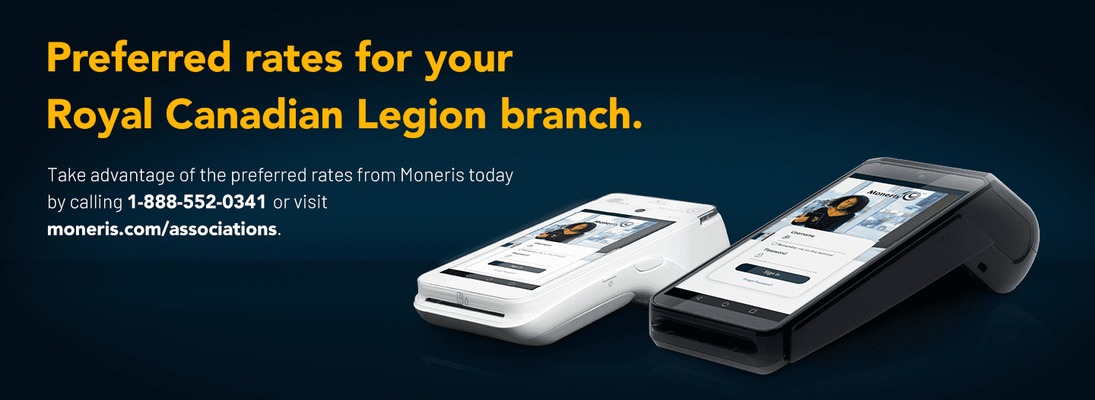
Whether your Branch wants to accept payments in-person, online, or via mobile devices, Moneris offers a variety of solutions that can meet your needs. In addition to the preferred rates, you can also enjoy services such as 24/7 support and stress-free set up.
Learn more ‣

2024 Royal Canadian Legion President’s Cruise –
10-Night Ultimate Southern Caribbean Onboard Celebrity Silhouette

Join Dominion President Bruce Julian and Darlene Julian, BST Vacations, and Royal Canadian Legion members from across Canada for a 10-night Ultimate Southern Caribbean Cruise on the innovative Celebrity Silhouette.
The cruise will be sailing to St. Maarten, St. Lucia, Tobago, Grenada, & Antigua – plus, four glorious days at sea relaxing on the Silhouette!
February 11–22, 2024
Book by May 2nd and enjoy savings of $200 per person!
Get more details ‣

Special offer from Legion Magazine

If you have any questions, please contact Member Services and we will be pleased to assist. 1-855-330-3344 or membership@legion.ca
Office Hours: Monday - Friday, 8:30 a.m. - 4:30 p.m. EST
Working together to serve Canada’s Veterans.

Click here if you are having trouble viewing this message
Copyright © 2023 The Royal Canadian Legion. All rights reserved.
Administrative emails from Legion National Headquarters are sent to the email address on file for your local Legion Branch. If this is no longer the correct email address for your Branch, please forward this email to the new contact and request the Branch update their contact information.
The Branch may update the email address at any time by updating their Branch Profile on the Member Services Website or by contacting Member Services. Learn more about All Branch emails.
Our contact information is:
The Royal Canadian Legion National Headquarters
Member Services Department
86 Aird Place
Ottawa, ON K2L 0A1
Canada
Toll free: 855-330-3344
E-mail: membership@legion.ca

