Do You Know a Veteran?

Hi,
At Canadian Cannabis Clinics our aim is to improve your quality of life through the therapeutic use of medical cannabis and give you a life filled with Better Days. We continuously listen to the needs of our patients and try to offer you services that will help you on your medical cannabis journey.
We know the Canadian Veteran community have an incredibly strong bond. It's in their nature to support and help each other through difficult situations. It is for this reason we have welcomed two Veterans to our team, Megan Canam and Jason Stewart, to provide additional support to Veteran patients at any stage of their medical cannabis journey.
Whether it's an initial conversation about medical cannabis or a technical question like navigating coverage - our Veteran ambassadors are there to help.
If you have a Veteran family member or friend who could benefit from medical cannabis and might wish to speak to fellow Veterans about their experience, they can reach Megan or Jason at veterans@cannabisclinics.com.
We proudly introduce Master Corporal Megan J.L. Canam, CD (Retired) and Master Corporal Jason C. Stewart, (Retired).

Meet Master Corporal Megan J.L. Canam, CD (Retired)

Your Veteran Ambassadors
Master Corporal Megan J.L. Canam, CD (Retired) and Master Corporal Jason C. Stewart, (Retired) are part of the team at Canadian Cannabis Clinics as Veteran’s Ambassadors. Their combined insight, advocacy and personal journeys make them an invaluable resource for Veterans at any stage of the medical cannabis journey.
Whether it is a technical question like navigating VAC coverage, or a personal connection to the medical cannabis veterans community you need – our ambassadors are here to help.

Meet Master Corporal Megan J.L. Canam, CD (Retired)
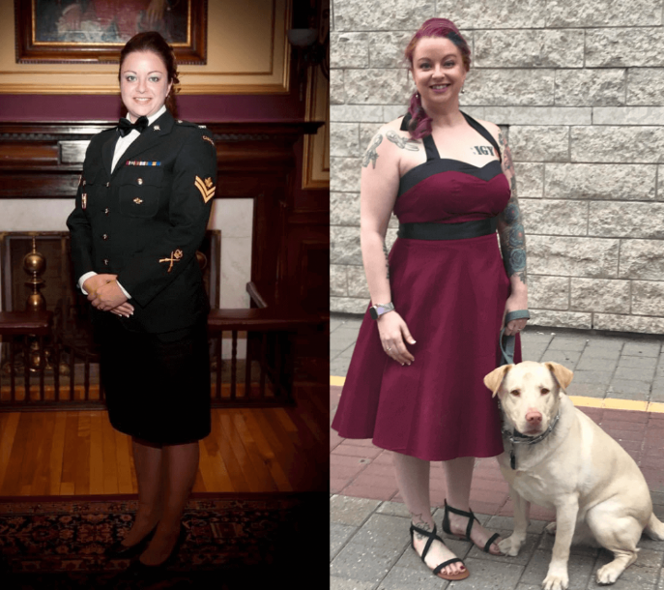
Megan Canam is a Veteran, single mother and cancer survivor.
Born in Halifax, Nova Scotia and growing up in Cole Harbour, from an early start Megan was a woman on the move. Active in soccer, track and field, competitive swimming, and ballet she still found time to be involved in her community as part of the local Girl Guide chapter – even travelling to Mexico to represent her province at the age of 14. After graduating high school, Megan went on to attend the local Saint Mary’s University for a Bachelor of Arts – Majoring in Criminology with a Minor in Psychology
After graduation, Megan jumped into a new passion – joining the military reserves as an Intelligence Operator in July 2002. In this role she received her first deployment to Bosnia from 2005-2006. On her return to Canada she made yet another big move, this time traveling halfway across the country to make Manitoba home. Not long after, Megan made her position with the Canadian Armed Forces full time, joining the regular force in 2008 as Intelligence Operator with Princess Patricia Canadian Light Infantry (PPCLI).
While with the PPCLI Megan was deployed to Afghanistan in 2009 and then moved to Kingston 2010 to teach at the Canadian Forces School of Military Intelligence (CFSMI) training future operators. Studious herself,
during her time with the Canadian Armed Forces Megan also completed programs in Forensic Sciences, Police Sciences, Investigations, and a Para Legal/Legal Assistant for a total of 4 separate diplomas on top of her
university degree.
Megan is a cancer survivor and thankfully, she has been in remission since 2012. That year marks another special highlight in Megan’s life as she welcomed her daughter into the world.
After retiring from the forces in 2017, Megan now lives in Kingston with her daughter and service dog Cody. After many struggles, Megan now lives for the daily love, encouragement and wet kisses she has come to expect from her small family.

Meet Master Corporal Jason C. Stewart, (Retired)
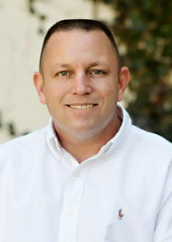
Jason Stewart has dedicated his life to the armed forces and the men and women who serve within it. Stationed with the Princess Patricia’s Canadian Light Infantry (PPCLI) first battalion from 1990 to 1997 Jason rose to the rank of Master Corporal within the rifle companies with a special stint in the Pioneer Platoon. During his time in the forces Jason also served with the United Nations in Croatia Sector South with UNPROFOR.
However, on December 12th, 1996 Jason’s military career changed forever.
An accident lead to his medical release from the Canadian Armed Forces and into the world of Veteran’s Affairs Canada (VAC). While he didn’t know it at the time, VAC had recently been revamped and was beginning to negotiate two systems of old and new charter coverage. Some hybrid veterans, like Jason, bridged the gap by qualifying for elements of both plans. While technically covered under two government programs, Jason quickly found himself locked in a 12-year battle to receive the full benefits promised by the country he served.
But Jason didn’t allow the experience to slow him down. He applied for, and received, a rehabilitation program to attend the University of Western Ontario to obtain an HBA in Business, with a specialty in Human Resources. Using what he knew about the differences between the (by this time) three veteran status’ Jason used his own experience to fuel his academics by writing about the complexities of VAC coverage.
Since graduation Jason has used the last 7 years to advocate on behalf of other former members of the
Canadian Forces and the Royal Canadian Mounted Police. After his own struggle with a complex and bureaucratic system, Jason views it as his duty to counsel others through the process, ensuring every veteran get the coverage they deserve.

