Legion news
Read the latest news releases and articles from Dominion Command of The Royal Canadian Legion.
Stay up to date, subscribe to Legion updates:
SUBSCRIBE

Joan Cook is The Royal Canadian Legion’s 2020 Marches Nijmegen Representative
9 March 2020

- Email
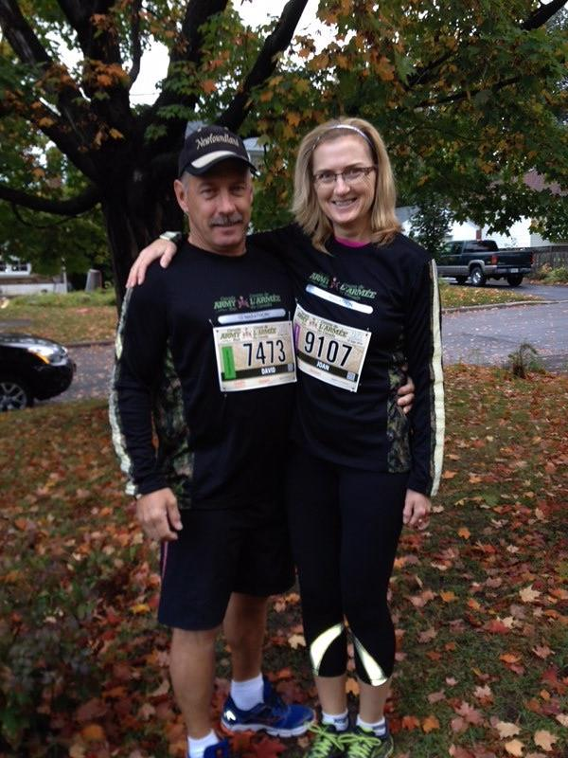Meet our 2020 Marches Nijmegen Representative!
Joan Cook is a 14-year Veteran of the Canadian Armed Forces, a current public servant with the RCMP and a member of the Kemptville, Ontario Legion Branch 212, with a strong family connection to our military history.
Between July 21 and 24, Joan will join the CAF contingent and tens of thousands of participants from all over the world, walking more than 40 km a day in the International Four Days Marches Nijmegen.
“Joan was chosen from dozens of impressive applications from across the country,” says Legion Dominion President Tom Irvine. “When making our selection, we look for an exemplary Legion member who understands the significance of the Nijmegen Marches, is physically active and would be proud to represent the Legion. We are very impressed with Joan’s background and we wish her well on this extraordinary adventure.”
We asked Joan a few questions about her opportunity to participate in the Nijmegen Marches.

What motivated you to apply for the Nijmegen March?
I grew up with a close connection to the Canadian military. My grandfather served in the Second World War on the SS Empire Bison torpedoed on November 1, 1940. My grandmother received the Silver (Memorial) Cross, which I have since inherited. My participation in the Nijmegen Marches would be the ultimate experience and another way to honour my grandfather, along with my father, husband and all those who served and paid the ultimate sacrifice.

How did you feel when you learned you were accepted?
There must have been many great candidates for this opportunity. To learn that I was selected to represent all those who put their name forward is such an honour. I’m excited and emotional that my and my family’s hard work and dedication to service is recognized.
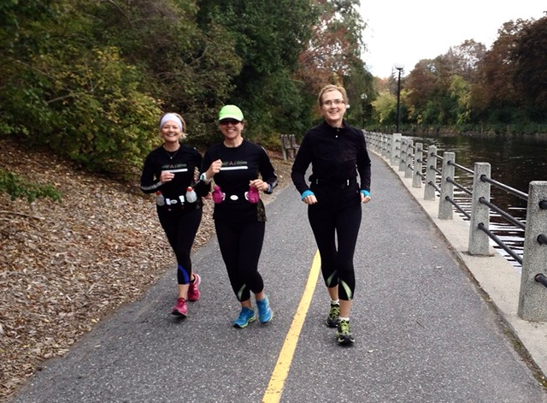

How will you train for the Marches?
I will continue my daily fitness regime of circuit training and walking several times a week.
To increase my training for the Nijmegen March, I will adopt the military’s training schedule and train with them when possible.

What are you looking forward to the most during the Nijmegen Marches?
I am looking forward to visiting and meeting the local community along with meeting other participants from different countries. I am also looking forward to being part of the many commemorative ceremonies that will take place. These will be life-changing moments. Of course, the demanding physical challenge and seeing Europe will also be amazing!
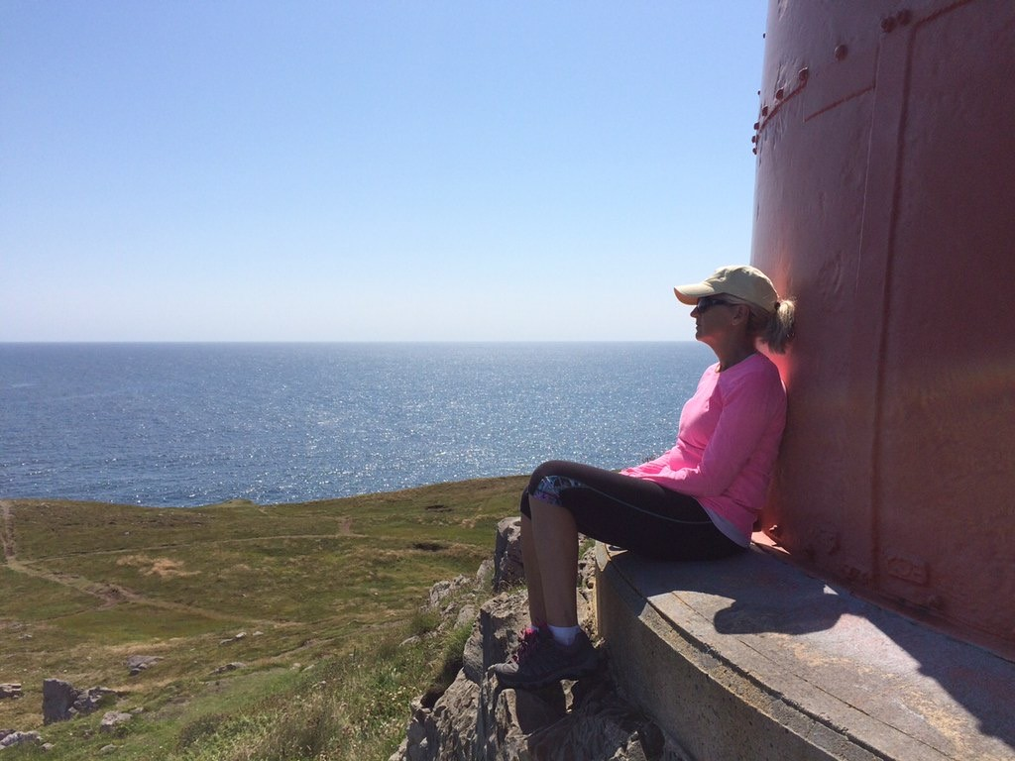

Why did you join the Legion?
I grew up in Newfoundland and looked up to my father who was very active in our local Legion right up to his passing in 2019. The Legion supports our Veterans and their families—my family has received tremendous support from the Legion. I joined to give back in any way I can and to honour my father, grandfather, husband and everyone who served and sacrificed for our country.

How has your experience as a Legion member been? What do you like best?
I am humbled and proud to be a Legion member. It feels great to be in a place where I feel like I belong. The Legion recognizes that a Veteran is a Veteran, no matter where or when you served. This belonging is something that I haven’t felt since I left the Canadian Armed Forces in 1996.
I also love all the different events that go on. The Legion is a wonderful place to bring the community together!

The Canadian Armed Forces traditionally invites a Legion member to join its team each year, in recognition of the Legion’s sponsorship of the team’s visit to Vimy Ridge while in Europe for the March.

Tens of thousands of military members and civilians take part in the Nijmegen Marches every year and thousands of spectators cheer them on. To learn more, please visit: https://www.4daagse.nl/en/

